AVIAN INFLUENZA

28 FEBRUARY 2017

NOTICE TO ALL ALLOTMENT HOLDERS WHO HAVE POULTRY

A CASE OF AVIAN INFLUENZA HAS BEEN CONFIRMED AT HALTWHISTLE AND RESTRICTIONS HAVE BEEN IMPLEMENTED WITHIN THE TWO RESTRICTED ZONES.

DEFRA HAVE UPDATES ON THEIR WEBSITE AND SPECIFIC AREAS OF THE COUNTRY ARE DEEMED HIGH RISK AREAS BECAUSE OF MIGRATORY WILDFOWL VISITING NATURE RESERVES.

BECAUSE NORTHUMBERLAND HAS NATURE RESERVES ON ITS COASTLINE IT MEANS ALL THE ALLOTMENT SITES IN BLYTH ARE DEEMED TO BE IN THE HIGH RISK AREA, THEREFORE THE PRESENT RESTRICTIONS WILL CONTINUE UP TO SUNDAY 30 APRIL 2017.

THE RESTRICTIONS DO NOT APPLY TO THOSE ALLOTMENT HOLDERS WHO HAVE RACING PIGEONS.

A COPY OF THE INFORMATION IS ALSO ON THE TOWN COUNCIL WEBSITE AND WILL BE UPDATED WHEN CHANGES ARE ANNOUNCED.

PLEASE OBSERVE GOOD BIO-SECURITY AT ALL TIMES.
IF YOU DISCOVER SICK BIRDS CONTACT DEFRA ON TEL NO 03000 200 301

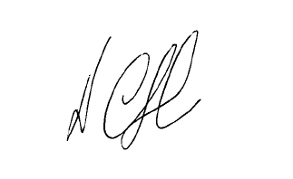

D CLOUGH
ALLOTMENT OFFICER

